**PORT SCANNING**

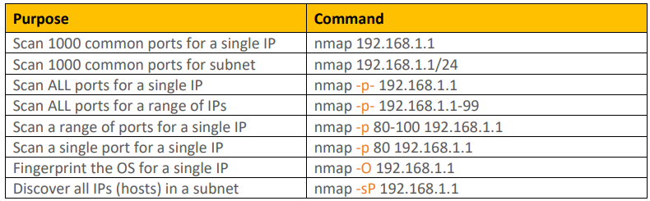

Scan 1000 common ports of your own system;

**nmap localhost**

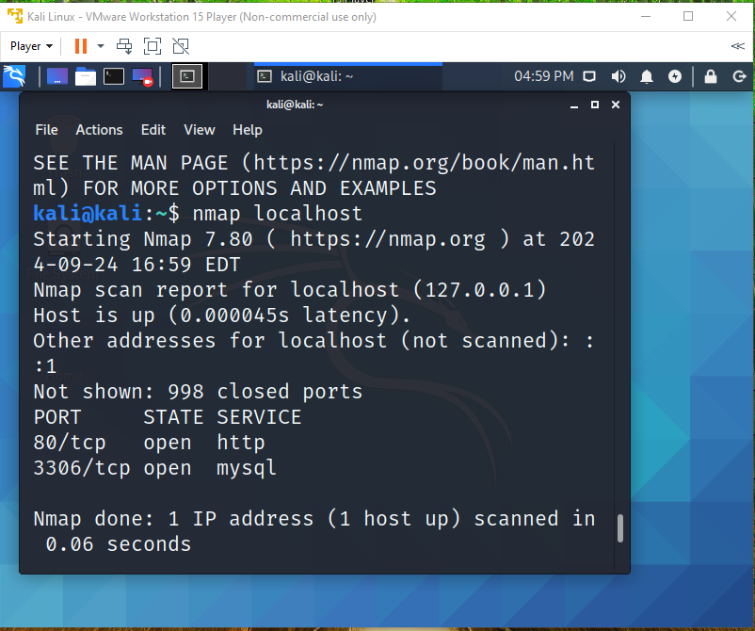

Scan ALL Ports

**nmap -p- localhost**

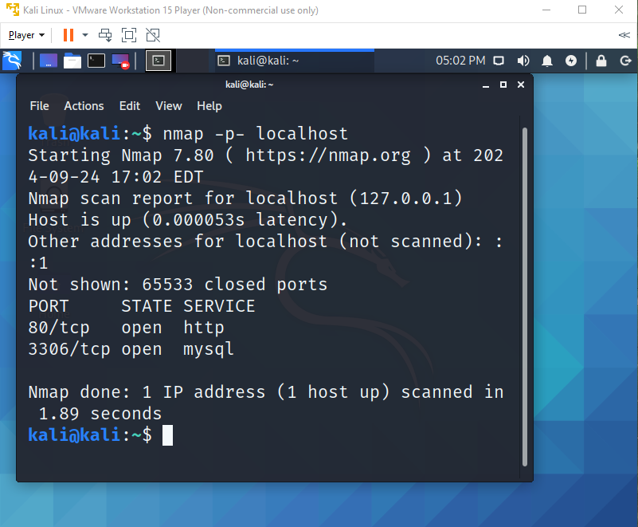

Scan Port 80

**nmap -p 80 localhost**

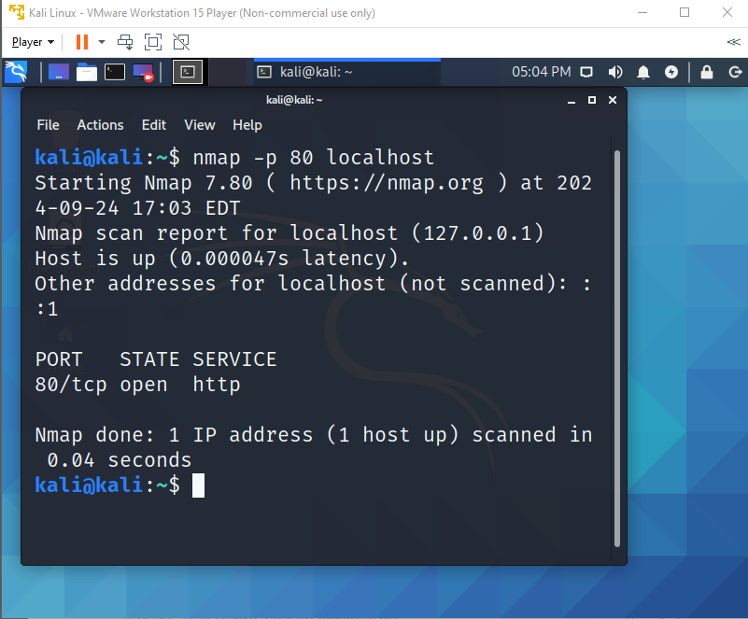

Fingerprint the Operating System

sudo nmap -O localhost (sudo for elevated privileges)

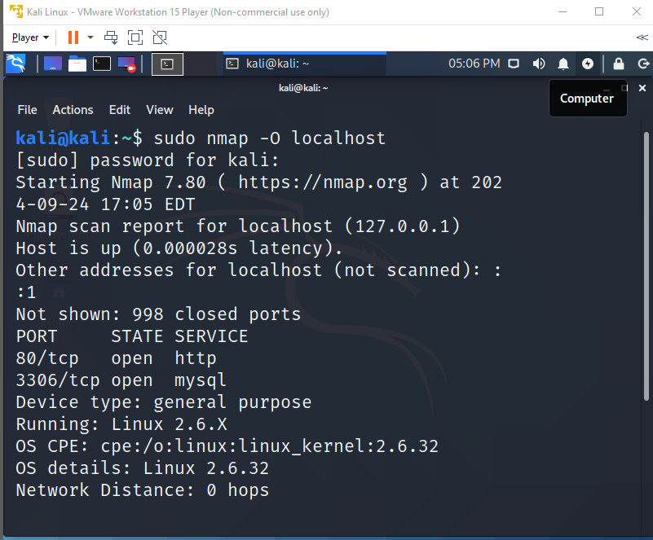

Continue fingerprint; find out the IP Address of the Ethernet Card that the VMWare machine is using.  
Issue the following command: ***ifconfig***

sudo ifconfig

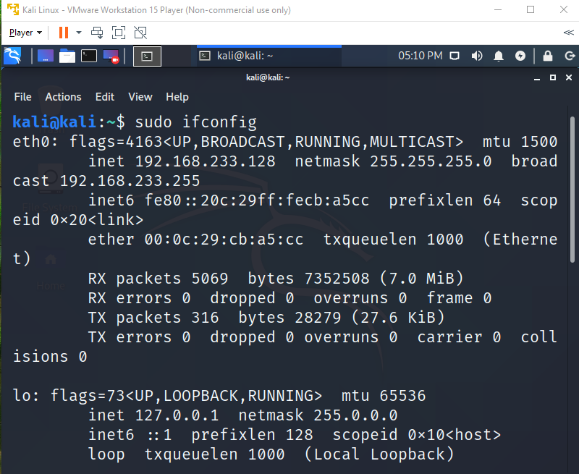

Discover all the IP Address within the subnet **nmap -sP [the IP Address *192.168.233.128/24*]** (/24 is its’ mask 255.255.255.0)

*sP is for ping sweep or ping scan to discover all the IP address within the subnet

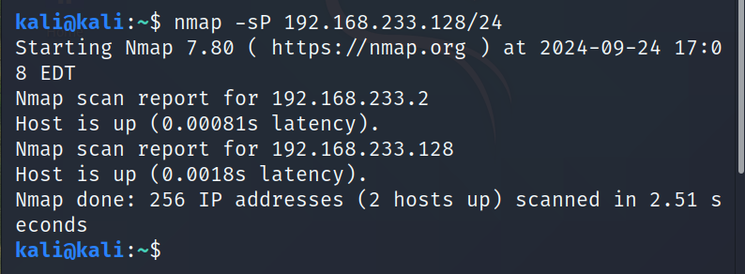

*Will display all the host which are running

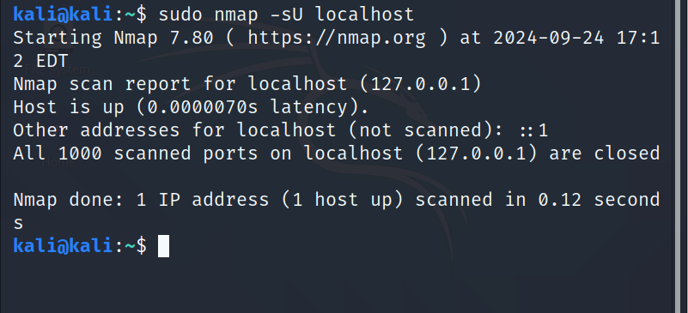

Scan port range 60-120

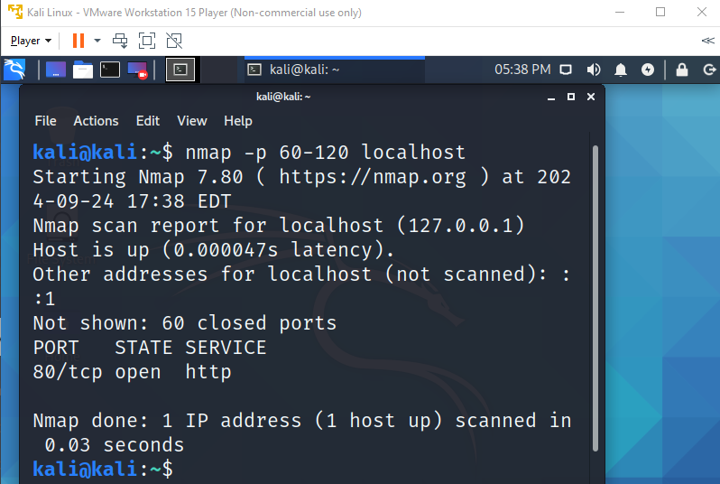

Scan for telnet port (24), scan only a single port

